Lab 3

Brandon P Trinkle

Arizona State University

Course Number: IFT 220

Professor Betty J. Lauer

March 30, 2024

Lab 3

DC01:

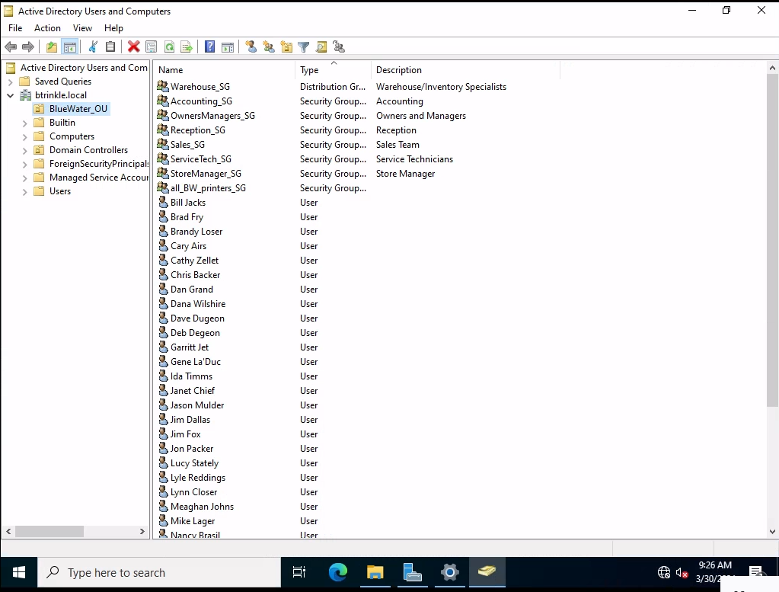

Creation of the BlueWater Organizational Unit

Shared directories

Accounting shared folder

Admin Shared folder

Pubic shared folder

Service tech shared folder

Warehouse shared folder

BlueWater home shared folder

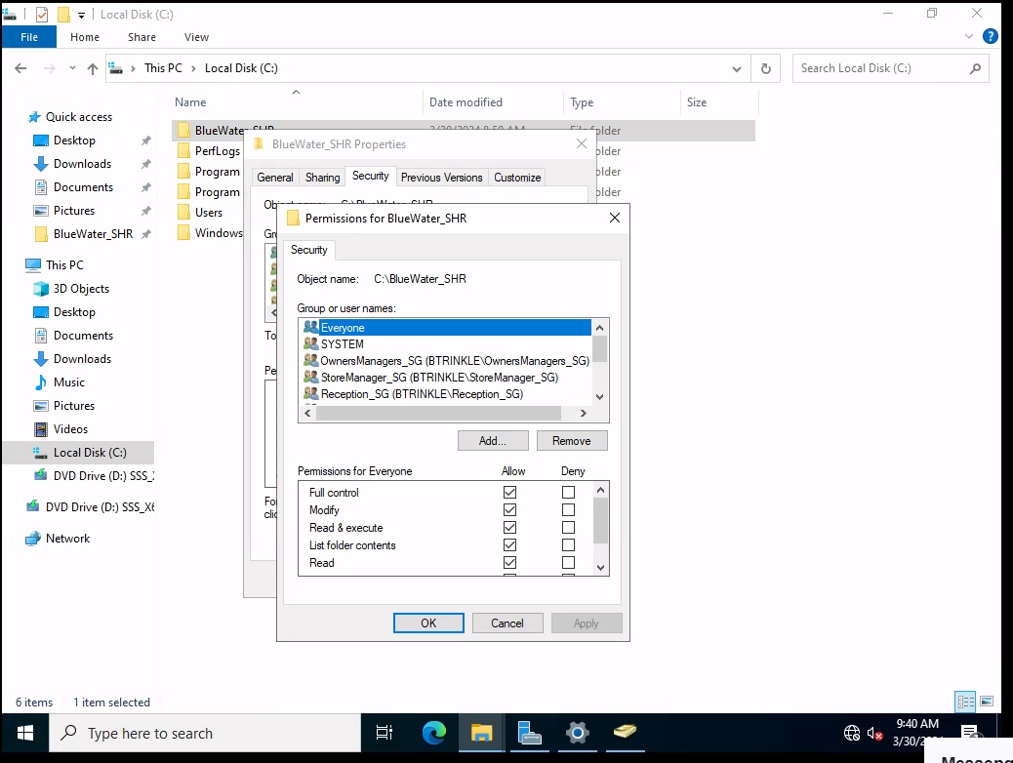

BlueWater home, shared with everyone.

Groups and users part 1

Groups and users part 2

Example of creating a group

Example of users in the group

Example of employee creation

Example of security groups they are enrolled in.

Sales logon restrictions.

Printer created and shared in directory

Printer shared with the security group

PC01:

Logged in as Jon Packer

**Summary:**

The completion of the Bluewater Spa and Pool Company lab provided a comprehensive learning experience, offering valuable insights into the establishment and management of an Active Directory (AD) environment. This reflection aims to outline the significant learnings derived from the lab, with a particular focus on organizational structure, access control mechanisms, and printer management within the AD framework.

Organizational units (OUs) emerged as fundamental components of efficient network administration within the Active Directory infrastructure. Through the creation and structuring of OUs, I gained a thorough understanding of their crucial role in facilitating streamlined administrative processes and optimizing resource allocation. OUs serve as the backbone of the network hierarchy, enabling the efficient management of users, groups, and resources based on specific organizational requirements and operational workflows. This practical exercise underscored the importance of establishing a well-defined and hierarchical OU structure within Active Directory, which serves as the foundation for seamless network management and administration.

Moreover, the lab highlighted the critical significance of access control mechanisms in safeguarding network security and upholding data integrity. By creating security groups, assignment of granular permissions, and configuration of logon hours, I gained firsthand insights into the implementation of robust access control policies. This hands-on experience illuminated the delicate balance between granting access to resources and protecting sensitive data from unauthorized access. Effective access control is paramount in network administration, serving as a linchpin in mitigating security risks and ensuring that users possess access privileges commensurate with their roles and responsibilities.

Printer management within Active Directory emerged as another pivotal aspect of network infrastructure administration explored during the lab. The process of configuring shared printers, assigning permissions, and implementing printer pooling provided invaluable insights into best practices for print resource optimization. Addressing the diverse printing needs of distinct user groups within the organization necessitates meticulous planning and configuration. This practical encounter underscored the importance of fine-tuning printer resources to enhance operational efficiency and productivity while simultaneously upholding stringent security protocols and access control measures.

Throughout the lab, attention to detail and unwavering adherence to industry best practices were emphasized as cornerstones of effective network administration. Each task, spanning from the creation of user accounts to the configuration of printer permissions, necessitated methodical planning and execution to uphold the integrity and security of the network infrastructure. Precision and adherence to established protocols are indispensable for safeguarding network assets and ensuring uninterrupted operational continuity, particularly within dynamic and evolving IT environments.

In conclusion, the completion of the Bluewater Spa and Pool Company lab provided valuable insights into the intricate domain of Active Directory administration. This hands-on experience not only improved my technical proficiency but also engendered a deeper appreciation for the fundamental principles underpinning network administration. Armed with newfound knowledge and practical acumen, I am poised to confront real-world challenges in IT administration with confidence and efficacy, thereby contributing substantively to the success and resilience of future network endeavors.

# References

Lauer, B. J. (2024, March 30). *Module 3/Lab 3*. Retrieved from Canvas IFT-220: https://canvas.asu.edu/courses/182822/files/82426769?wrap=1